**KWoC FINAL EVALUATION REPORT**

**Name :: RISHABH JAIN**

**Github handle ::** [**rishabh214**](https://github.com/rishabh214)

**Email :: jainr214@gmail.com**

**Jaypee Institute of Information Technology (JIIT)**

**Project ::** [**CERTIFY**](https://github.com/kbhutani0001/Certify)

**Mentor ::** [**Kartikay Bhutani**](https://github.com/kbhutani0001)

**About KWoC**

KWoC (Kharagpur Winter Of Code) is an annual open source program conducted by Kharagpur Open Source Society(KOSS), IIT Kharagpur. Kharagpur Winter of Code is a 5-week long online program for students who are new to open source software development. Students can contribute and work on projects listed on the website. Students can also become mentors by posting their project details and urging fellow programmers to work on it. This develops leadership qualities in students. The program not only helps students to get involved in open source but also prepares them for many open source summer programs; Google Summer of Code being one of them.

**ABOUT CERTIFY**

Certify is a project which is developed to generate certificates or invitations for a large number of people. It has huge application in college fests and competitions. A spreadsheet file and a template should be uploaded by the user. The field in the spreadsheet will be automatically detected. User can position those fields and place them on the template accordingly. All the files can be later downloaded. A verification code is also added on the certificate in order to ensure validity.

**Detailed Working**

Different technologies have been used in the project. The back end of the project is developed in python programming language. When pre designed certificate/invitation template and a spreadsheet containing details to be put on certificates/invitations is uploaded, Fields of spreadsheets are automatically detected using pandas library. Each field is represented by a draggable text box which can be clicked and dragged to suitable position. Coordinates of the top left corner of the draggable textbox are first adjusted with respect to the template and are then returned and stored in a dictionary. Different fonts variable sizes can be chosen. Font color of the text can also be changed if wished. It is set to black on default. Pillow module is used in the editing part of image. Values of different columns are placed at specified coordinates and are centre aligned so that it looks similar for all value lengths. A unique certificate code is added on the certificate in order to avoid fake certificates. With help of this code certificates can be easily verifid New images are generated for data of each row. All images can be downloaded in a zip file.

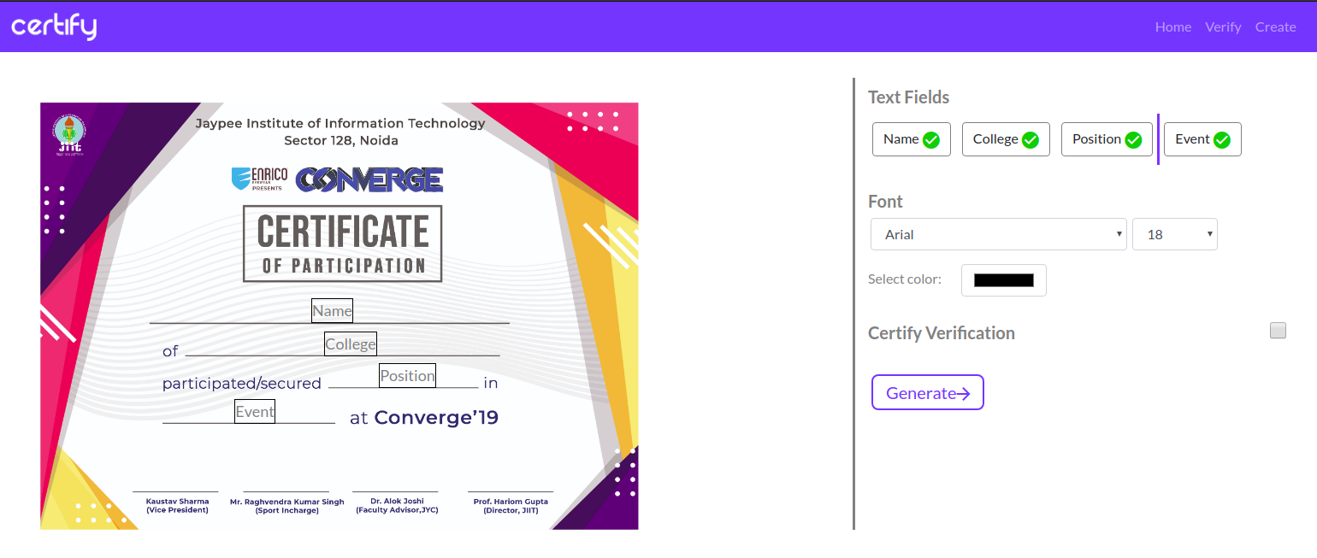

Edit Page

**MY CONTRIBUTION**

The issue which I worked on was center alignment of text on the template. Initially the values which were to be printed on template were left aligned. The problem with left alignment was that values with variable length (either too short or too long values) when printed looked very odd. The values left a lot of blank space as shown in figure

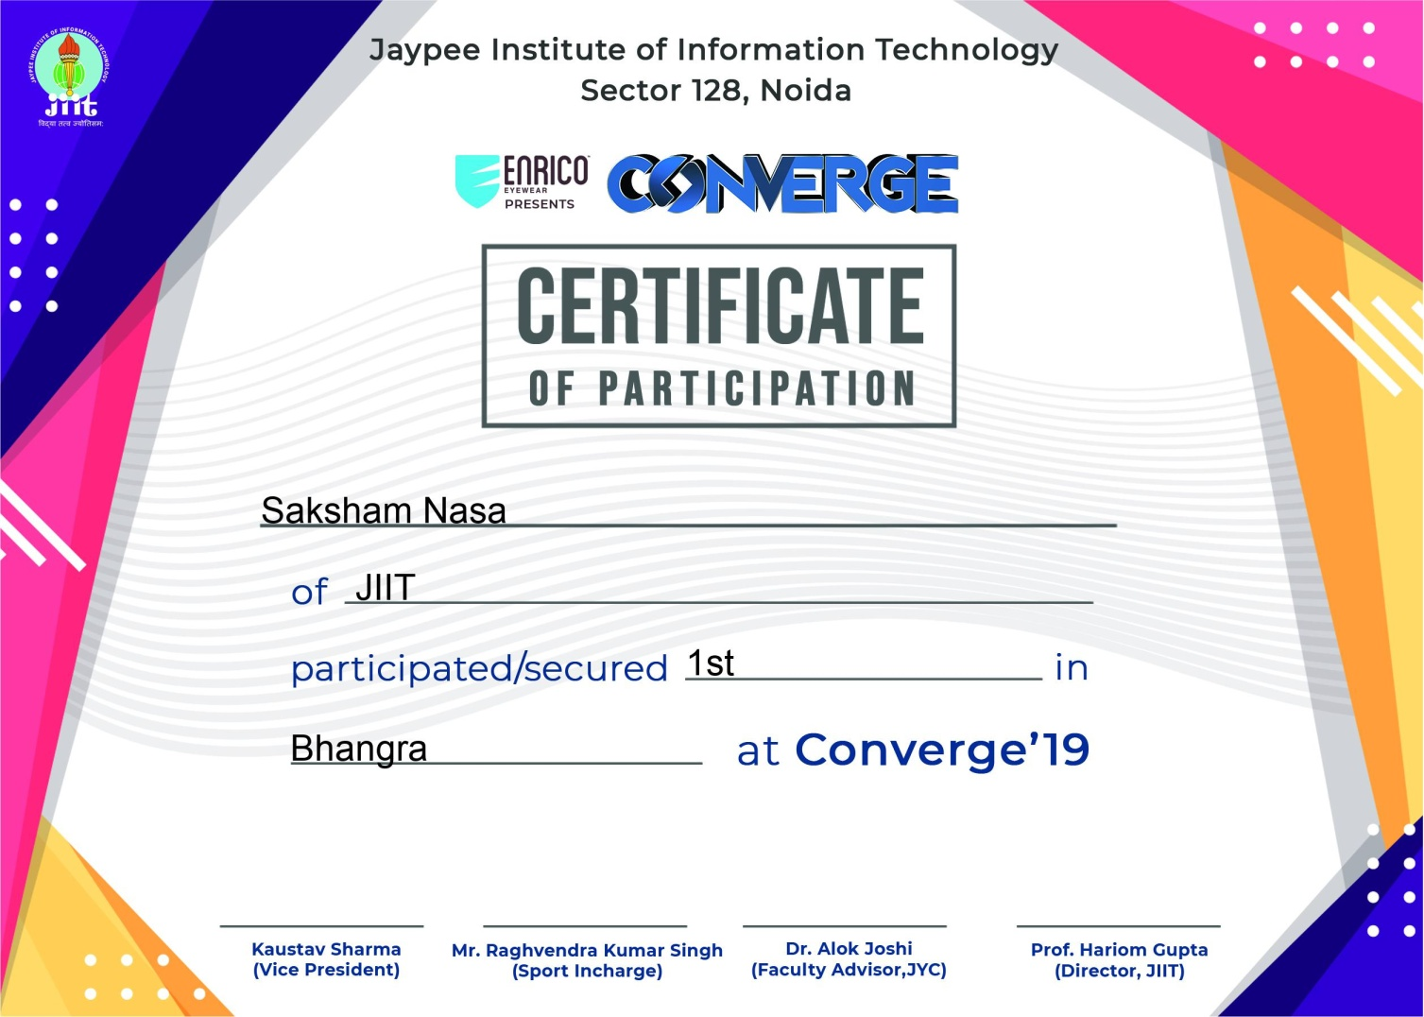

Python pillow module is used to edit and write text on images. It can also be used to resize images. In this project this module is used in order to write data given in a spreadsheet on a template. The template is opened using Image.open() and edited using ImageDraw.Draw(). The values are written using draw.text() function of ImageDraw module. draw.text() requires x and y coordinates of position you want your text to be placed. It also takes the text to be placed and font as arguments. The x and y coordinates are returned from getcoordinates() function in main.js file and are stored in values dictionary.

First PR

The logic I used to center align text was ,To shift the text, to the left of the draggble textbox center, by half of the text-length. For each item in spreadsheet, length was calculated using Draw.textsize() function which returns width and height of the text.The center of the draggable text box was calculated by shifting the x,y coordinates to the right by half of textbox-width. The center of the draggable textbox should coincide with the center of the text-length.

To calculate the center of the draggable textbox I used .offsetWidth function which returned the width of textbox. Then I modified the returning x and y coordinates by adding half of the textbox width to the x coordinates so that it points to the center of the textbox.

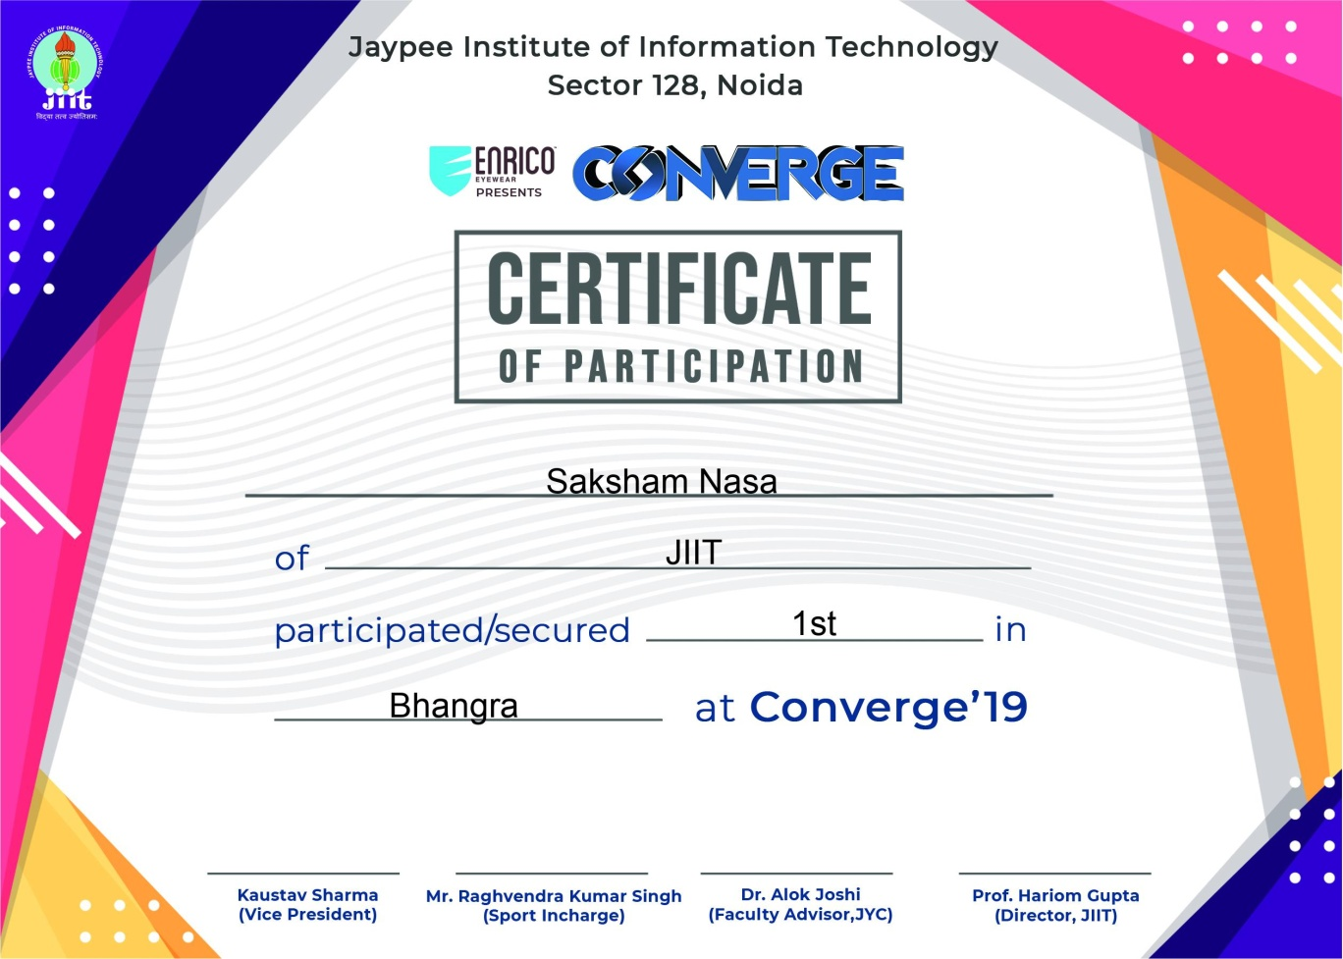

Second PR

First PR worked fine but had one issue, Calculation of length of text was sometimes inaccurate as we used Draw.textsize() function. It showed error with low pixel images as it considers every character to be 6 pixels wide. whereas an “I” takes max. 2 pixels and a “W” takes min. 8 pixels (in my case).

So in the second PR I used .getsize() function which was more accurate than Draw.textsize()